1831MayDaySatire

May Day by John ('HB') Doyle

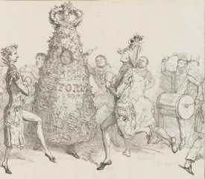
https://www.npg.org.uk/collections/search/portrait/mw206400/May-Day?set=395%3BPolitical+Sketches+by+H.B.+%28vol+II%29&displayNo=20&wPage=1&search=ap&rNo=22
© National Portrait Gallery, London

